DevOps Project – Deploying a simple HTML onto tomcat server.
Objective: Main objective of this project is to integrate multiple DevOps tools.
Stage 1: Using Terraform to Launch 3 Instances
Stage 2: Instance 1: Jenkins
Instance 2: Ansible
Instance 3: Tomcat Webserver
Stage 3: Deploying the Html code to the Tomcat Server

Stage 1: Using Terraform to Launch 3 Instances.
- Writing Scripts:
Ec2-instance.tf
resource "aws_instance" "project1" {
instance_type= "t2.micro"
key_name = "testkey"
count = 3
ami= "ami-0a6b2839d44d781b2"
}

Providers.tf
provider "aws" {
# Configuration options
region = "us-east-1"
}

- Cmd: Terraform Init
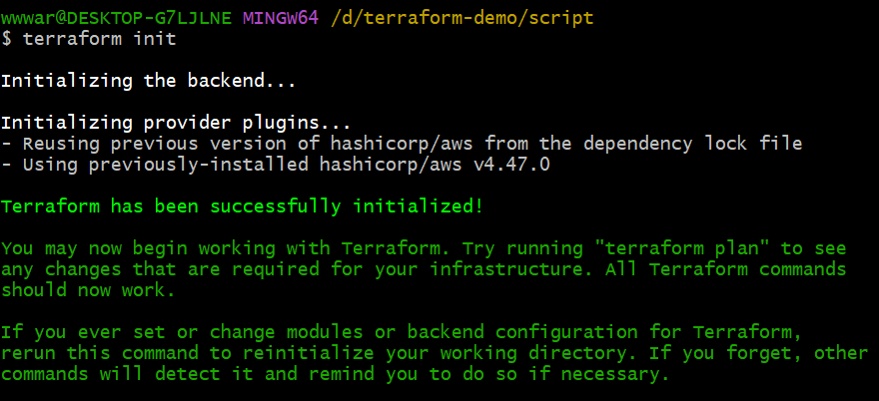
- Cmd: Terraform plan – Probable output/Dry run
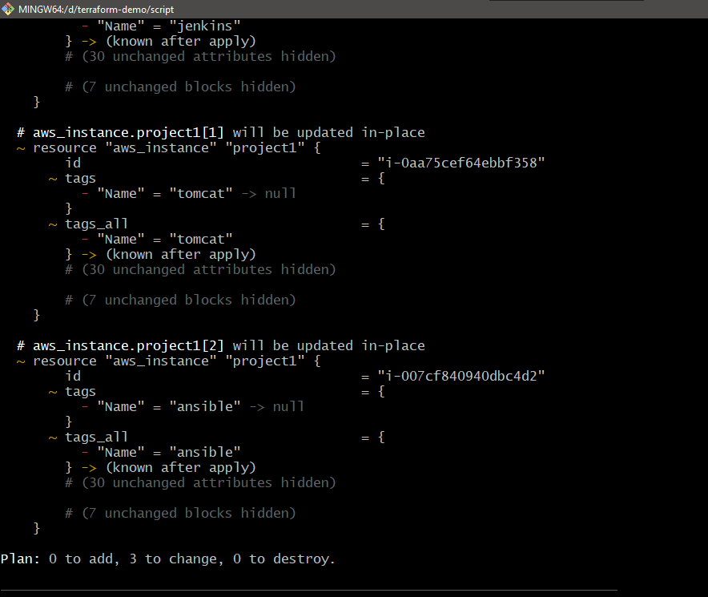
- Cmd: Terraform Apply
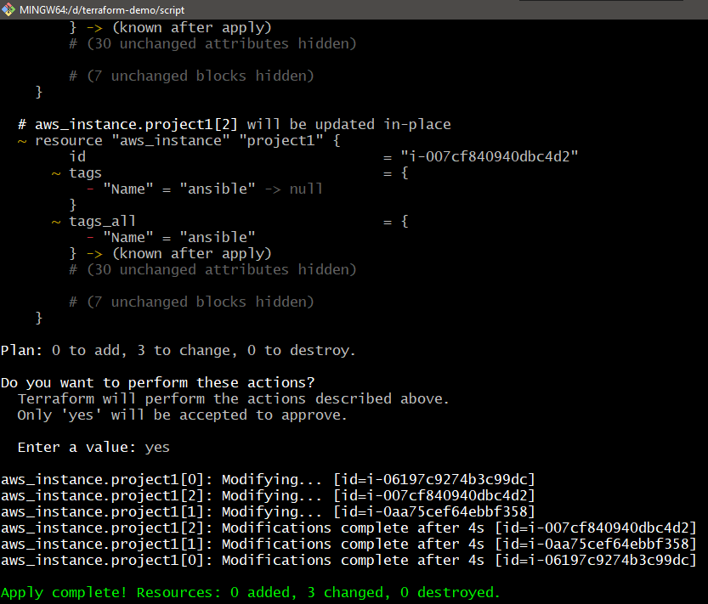

Stage 2: Setting Up Jenkins
Ssh to the first instance:
ssh -i key.pem ubuntu@IP address
Java is a pre-requisite to install Jenkins
Installing Java
=========================================
1. sudo apt update
2. sudo apt install openjdk-11-jre -y
3. java -version

Installing Jenkins
==========================================
1. curl -fsSL https://pkg.jenkins.io/debian-stable/jenkins.io.key | sudo tee \
/usr/share/keyrings/jenkins-keyring.asc > /dev/null
2. echo deb [signed-by=/usr/share/keyrings/jenkins-keyring.asc] \
https://pkg.jenkins.io/debian-stable binary/ | sudo tee \
/etc/apt/sources.list.d/jenkins.list > /dev/null
3. sudo apt-get update
4. sudo apt-get install jenkins -y
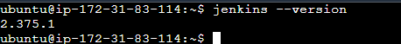
Setting up the Jenkins:
- Login to jenkins by filling up the Credentials
- Install the suggested plugins
- Install the plugins : Publish over SSH, Maven
Setting up Publish over SSH: For Ansible Server
Changing the sshd_Config file: Sudo vi /etc/ssh/sshd_config

Changing the PasswordAuthentication no = PasswordAuthentication yes
# For this to work you will also need host keys in /etc/ssh/ssh_known_hosts
#HostbasedAuthentication no
# Change to yes if you don't trust ~/.ssh/known_hosts for
# HostbasedAuthentication
#IgnoreUserKnownHosts no
# Don't read the user's ~/.rhosts and ~/.shosts files
#IgnoreRhosts yes

# To disable tunneled clear text passwords, change to no here!
PasswordAuthentication yes
#PermitEmptyPasswords no

# Change to yes to enable challenge-response passwords (beware issues with
# some PAM modules and threads)
ChallengeResponseAuthentication no

# Kerberos options
#KerberosAuthentication no
#KerberosOrLocalPasswd yes
#KerberosTicketCleanup yes
#KerberosGetAFSToken no

# GSSAPI options
#GSSAPIAuthentication no

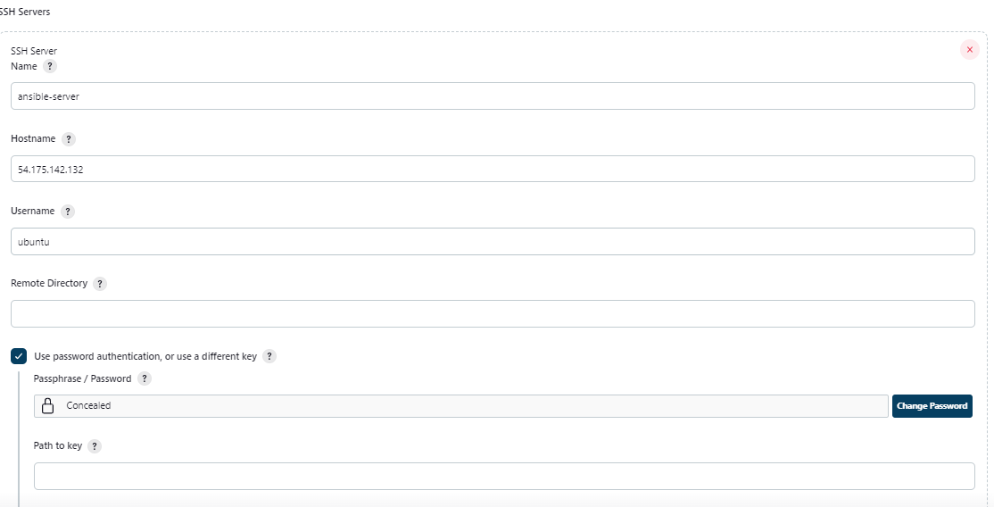

1.Add the username of the ansible server and the password.
you can set the password by switching to root user and use the command:
passwd username

2. Setting up Ansible controller
Install Ansible:
sudo apt update
sudo apt install software-properties-common
sudo add-apt-repository --yes --update ppa:ansible/ansible
sudo apt install ansible -y

Create a Ansible.cfg file:
[defaults]
Inventory= ./hosts

3. Create a hosts file with websever IP Address.
Write a playbook: Copyfile.yml
---
- hosts: all
become: true
tasks:
- name: copy file to the webserver
copy:
src: /home/ubuntu/playbooks/webapp/target/webapp.war
dest: /opt/apache-tomcat-10.0.27/webapps

- create a ssh-keygen to connect to the webserver seamlessly
- cmd: ssh-keygen – and copy the key
- Goto the tomcat server and use the command vi .ssh/authorized_keys and paste the key for connecting the webserver to the ansible server without any password.

Step 3 : Setting up the tomcat server

Tomcat installation on EC2 instance
Pre-requisites
EC2 instance with Java 11
Install Apache Tomcat
Download tomcat packages from https://tomcat.apache.org/download-80.cgi onto /opt on EC2 instance
Note: Make sure you change <version> with the tomcat version which you download.

# Create tomcat directory
cd /opt
wget http://mirrors.fibergrid.in/apache/tomcat/tomcat-8/v10.0.27/bin/apache-tomcat-10.0.27.tar.gz
tar -xvzf /opt/apache-tomcat-<version>.tar.gz
give executing permissions to startup.sh and shutdown.sh which are under bin.
chmod +x /opt/apache-tomcat-<version>/bin/startup.sh
chmod +x /opt/apache-tomcat-<version>/bin/shutdown.sh
Note: you may get below error while starting tomcat incase if you dont install Java
Neither the JAVA_HOME nor the JRE_HOME environment variable is defined At least one of these environment variable is needed to run this program

create link files for tomcat startup.sh and shutdown.sh
ln -s /opt/apache-tomcat-<version>/bin/startup.sh /usr/local/bin/tomcatup
ln -s /opt/apache-tomcat-<version>/bin/shutdown.sh /usr/local/bin/tomcatdown
tomcatup
Check point :
access tomcat application from browser on port 8080

http://<Public_IP>:8080
Using unique ports for each application is a best practice in an environment. But tomcat and Jenkins runs on ports number 8080. Hence lets change tomcat port number to 8090. Change port number in conf/server.xml file under tomcat home

cd /opt/apache-tomcat-<version>/conf
# update port number in the "connecter port" field in server.xml
# restart tomcat after configuration update
tomcatdown
tomcatup
Check point :
Access tomcat application from browser on port 8090

http://<Public_IP>:8090
now application is accessible on port 8090. but tomcat application doesnt allow to login from browser. changing a default parameter in context.xml does address this issue
#search for context.xml
find / -name context.xml
above command gives 3 context.xml files. comment () Value ClassName field on files which are under webapp directory. After that restart tomcat services to effect these changes. At the time of writing this lecture below 2 files are updated.
/opt/tomcat/webapps/host-manager/META-INF/context.xml
/opt/tomcat/webapps/manager/META-INF/context.xml

# Restart tomcat services
tomcatdown
tomcatup
Update users information in the tomcat-users.xml file go to tomcat home directory and Add below users to conf/tomcat-users.xml file
<role rolename="manager-gui"/>
<role rolename="manager-script"/>
<role rolename="manager-jmx"/>
<role rolename="manager-status"/>
<user username="admin" password="admin" roles="manager-gui, manager-script, manager-jmx, manager-status"/>
<user username="deployer" password="deployer" roles="manager-script"/>
<user username="tomcat" password="s3cret" roles="manager-gui"/>
Restart serivce and try to login to tomcat application from the browser. This time it should be Successful.

Stage 3: Create a Maven type project in Jenkins
- Provide the link of the GitHub repo: https://github.com/arshavardan/Project-1.git
- Under the build give the path of pom.xml file and give goal as: clean install package
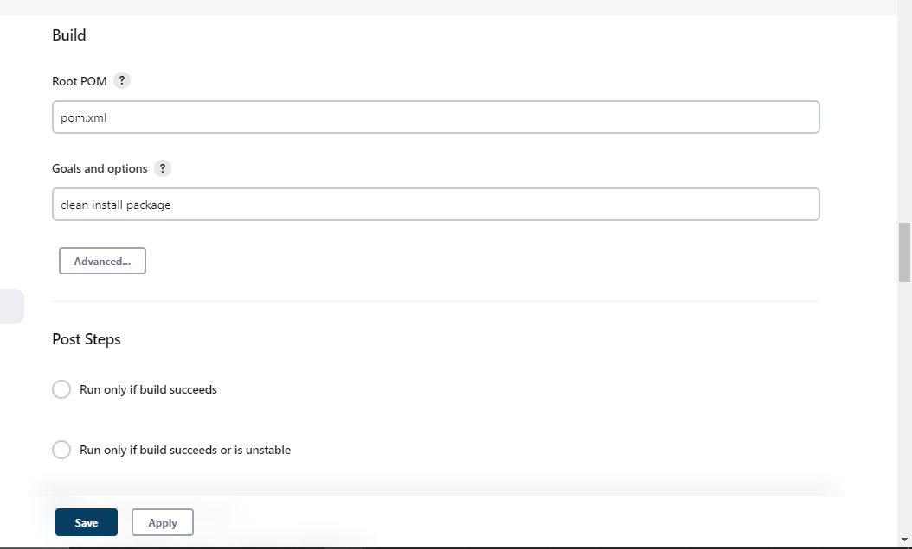
- Under post steps use command: send files or exec commands over SSH
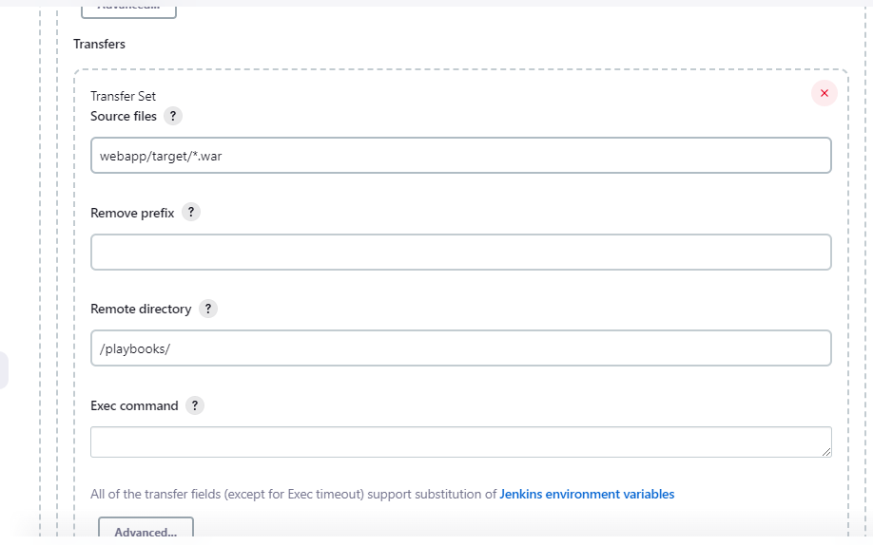

- Under the commands run the Ansible playbook:
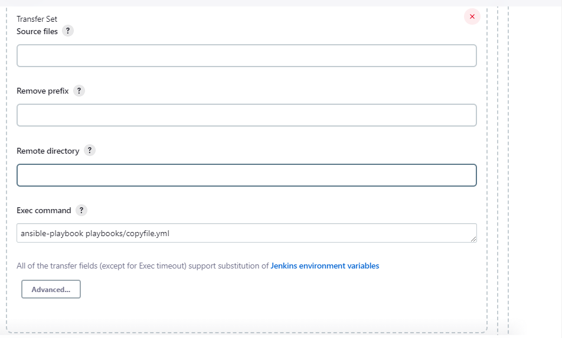
- Execute the build:
Console output:
Started by user Jenkins Admin
Running as SYSTEM
Building in workspace /var/lib/jenkins/workspace/project-1
The recommended git tool is: NONE
No credentials specified
> git rev-parse --resolve-git-dir /var/lib/jenkins/workspace/project-1/.git # timeout=10
Fetching changes from the remote Git repository
> git config remote.origin.url https://github.com/arshavardan/Project-1.git # timeout=10
Fetching upstream changes from https://github.com/arshavardan/Project-1.git
> git --version # timeout=10
> git --version # 'git version 2.25.1'
> git fetch --tags --force --progress -- https://github.com/arshavardan/Project-1.git +refs/heads/*:refs/remotes/origin/* # timeout=10
> git rev-parse refs/remotes/origin/master^{commit} # timeout=10
Checking out Revision f9ee8ec00216af7e66b9ea25dbba09d9561f114f (refs/remotes/origin/master)
> git config core.sparsecheckout # timeout=10
> git checkout -f f9ee8ec00216af7e66b9ea25dbba09d9561f114f # timeout=10
Commit message: "Update index.jsp"
> git rev-list --no-walk d60ab789d668fab44a5fab3c40fae7b871c63791 # timeout=10
Parsing POMs
Established TCP socket on 41389
[project-1] $ /usr/lib/jvm/java-11-openjdk-amd64/bin/java -cp /var/lib/jenkins/plugins/maven-plugin/WEB-INF/lib/maven35-agent-1.14.jar:/usr/share/maven/boot/plexus-classworlds-2.x.jar:/usr/share/maven/conf/logging jenkins.maven3.agent.Maven35Main /usr/share/maven /var/cache/jenkins/war/WEB-INF/lib/remoting-3071.v7e9b_0dc08466.jar /var/lib/jenkins/plugins/maven-plugin/WEB-INF/lib/maven35-interceptor-1.14.jar /var/lib/jenkins/plugins/maven-plugin/WEB-INF/lib/maven3-interceptor-commons-1.14.jar 41389
<===[JENKINS REMOTING CAPACITY]===>channel started
Executing Maven: -B -f /var/lib/jenkins/workspace/project-1/pom.xml clean install package
WARNING: An illegal reflective access operation has occurred
WARNING: Illegal reflective access by com.google.inject.internal.cglib.core.$ReflectUtils$1 (file:/usr/share/maven/lib/guice.jar) to method java.lang.ClassLoader.defineClass(java.lang.String,byte[],int,int,java.security.ProtectionDomain)
WARNING: Please consider reporting this to the maintainers of com.google.inject.internal.cglib.core.$ReflectUtils$1
WARNING: Use --illegal-access=warn to enable warnings of further illegal reflective access operations
WARNING: All illegal access operations will be denied in a future release
[INFO] Scanning for projects...
[WARNING]
[WARNING] Some problems were encountered while building the effective model for com.example.maven-project:server:jar:1.0-SNAPSHOT
[WARNING] Reporting configuration should be done in <reporting> section, not in maven-site-plugin <configuration> as reportPlugins parameter.
[WARNING]
[WARNING] Some problems were encountered while building the effective model for com.example.maven-project:webapp:war:1.0-SNAPSHOT
[WARNING] Reporting configuration should be done in <reporting> section, not in maven-site-plugin <configuration> as reportPlugins parameter.
[WARNING]
[WARNING] Some problems were encountered while building the effective model for com.example.maven-project:maven-project:pom:1.0-SNAPSHOT
[WARNING] Reporting configuration should be done in <reporting> section, not in maven-site-plugin <configuration> as reportPlugins parameter. @ line 51, column 24
[WARNING]
[WARNING] It is highly recommended to fix these problems because they threaten the stability of your build.
[WARNING]
[WARNING] For this reason, future Maven versions might no longer support building such malformed projects.
[WARNING]
[WARNING] The project com.example.maven-project:maven-project:pom:1.0-SNAPSHOT uses prerequisites which is only intended for maven-plugin projects but not for non maven-plugin projects. For such purposes you should use the maven-enforcer-plugin. See https://maven.apache.org/enforcer/enforcer-rules/requireMavenVersion.html
[INFO] ------------------------------------------------------------------------
[INFO] Reactor Build Order:
[INFO]
[INFO] Maven Project [pom]
[INFO] Server [jar]
[INFO] Webapp [war]
[INFO]
[INFO] --------------< com.example.maven-project:maven-project >---------------
[INFO] Building Maven Project 1.0-SNAPSHOT [1/3]
[INFO] --------------------------------[ pom ]---------------------------------
[INFO]
[INFO] --- maven-clean-plugin:2.5:clean (default-clean) @ maven-project ---
[INFO]
[INFO] --- maven-install-plugin:2.4:install (default-install) @ maven-project ---
[INFO] Installing /var/lib/jenkins/workspace/project-1/pom.xml to /var/lib/jenkins/.m2/repository/com/example/maven-project/maven-project/1.0-SNAPSHOT/maven-project-1.0-SNAPSHOT.pom
[INFO]
[INFO] ------------------< com.example.maven-project:server >------------------
[INFO] Building Server 1.0-SNAPSHOT [2/3]
[INFO] --------------------------------[ jar ]---------------------------------
[INFO]
[INFO] --- maven-clean-plugin:2.5:clean (default-clean) @ server ---
[INFO] Deleting /var/lib/jenkins/workspace/project-1/server/target
[INFO]
[INFO] --- maven-resources-plugin:2.5:resources (default-resources) @ server ---
[debug] execute contextualize
[INFO] Using 'utf-8' encoding to copy filtered resources.
[INFO] skip non existing resourceDirectory /var/lib/jenkins/workspace/project-1/server/src/main/resources
[INFO]
[INFO] --- maven-compiler-plugin:2.3.2:compile (default-compile) @ server ---
[INFO] Compiling 1 source file to /var/lib/jenkins/workspace/project-1/server/target/classes
[INFO]
[INFO] --- maven-resources-plugin:2.5:testResources (default-testResources) @ server ---
[debug] execute contextualize
[INFO] Using 'utf-8' encoding to copy filtered resources.
[INFO] skip non existing resourceDirectory /var/lib/jenkins/workspace/project-1/server/src/test/resources
[INFO]
[INFO] --- maven-compiler-plugin:2.3.2:testCompile (default-testCompile) @ server ---
[INFO] Compiling 1 source file to /var/lib/jenkins/workspace/project-1/server/target/test-classes
[INFO]
[INFO] --- maven-surefire-plugin:2.11:test (default-test) @ server ---
[INFO] Surefire report directory: /var/lib/jenkins/workspace/project-1/server/target/surefire-reports

-------------------------------------------------------
T E S T S
-------------------------------------------------------
Running com.example.TestGreeter
Tests run: 2, Failures: 0, Errors: 0, Skipped: 0, Time elapsed: 0.143 sec

Results :

Tests run: 2, Failures: 0, Errors: 0, Skipped: 0

[JENKINS] Recording test results
[INFO]
[INFO] --- maven-jar-plugin:2.4:jar (default-jar) @ server ---
[INFO] Building jar: /var/lib/jenkins/workspace/project-1/server/target/server.jar
[INFO]
[INFO] --- maven-install-plugin:2.4:install (default-install) @ server ---
[INFO] Installing /var/lib/jenkins/workspace/project-1/server/target/server.jar to /var/lib/jenkins/.m2/repository/com/example/maven-project/server/1.0-SNAPSHOT/server-1.0-SNAPSHOT.jar
[INFO] Installing /var/lib/jenkins/workspace/project-1/server/pom.xml to /var/lib/jenkins/.m2/repository/com/example/maven-project/server/1.0-SNAPSHOT/server-1.0-SNAPSHOT.pom
[INFO]
[INFO] --- maven-resources-plugin:2.5:resources (default-resources) @ server ---
[debug] execute contextualize
[INFO] Using 'utf-8' encoding to copy filtered resources.
[INFO] skip non existing resourceDirectory /var/lib/jenkins/workspace/project-1/server/src/main/resources
[INFO]
[INFO] --- maven-compiler-plugin:2.3.2:compile (default-compile) @ server ---
[INFO] Nothing to compile - all classes are up to date
[INFO]
[INFO] --- maven-resources-plugin:2.5:testResources (default-testResources) @ server ---
[debug] execute contextualize
[INFO] Using 'utf-8' encoding to copy filtered resources.
[INFO] skip non existing resourceDirectory /var/lib/jenkins/workspace/project-1/server/src/test/resources
[INFO]
[INFO] --- maven-compiler-plugin:2.3.2:testCompile (default-testCompile) @ server ---
[INFO] Nothing to compile - all classes are up to date
[INFO]
[INFO] --- maven-surefire-plugin:2.11:test (default-test) @ server ---
[INFO] Skipping execution of surefire because it has already been run for this configuration
[JENKINS] Recording test results
[INFO]
[INFO] --- maven-jar-plugin:2.4:jar (default-jar) @ server ---
[INFO]
[INFO] ------------------< com.example.maven-project:webapp >------------------
[INFO] Building Webapp 1.0-SNAPSHOT [3/3]
[INFO] --------------------------------[ war ]---------------------------------
[INFO]
[INFO] --- maven-clean-plugin:2.5:clean (default-clean) @ webapp ---
[INFO] Deleting /var/lib/jenkins/workspace/project-1/webapp/target
[INFO]
[INFO] --- maven-resources-plugin:2.5:resources (default-resources) @ webapp ---
[debug] execute contextualize
[INFO] Using 'utf-8' encoding to copy filtered resources.
[INFO] skip non existing resourceDirectory /var/lib/jenkins/workspace/project-1/webapp/src/main/resources
[INFO]
[INFO] --- maven-compiler-plugin:2.3.2:compile (default-compile) @ webapp ---
[INFO] No sources to compile
[INFO]
[INFO] --- maven-resources-plugin:2.5:testResources (default-testResources) @ webapp ---
[debug] execute contextualize
[INFO] Using 'utf-8' encoding to copy filtered resources.
[INFO] skip non existing resourceDirectory /var/lib/jenkins/workspace/project-1/webapp/src/test/resources
[INFO]
[INFO] --- maven-compiler-plugin:2.3.2:testCompile (default-testCompile) @ webapp ---
[INFO] No sources to compile
[INFO]
[INFO] --- maven-surefire-plugin:2.11:test (default-test) @ webapp ---
[INFO] No tests to run.
[INFO] Surefire report directory: /var/lib/jenkins/workspace/project-1/webapp/target/surefire-reports

-------------------------------------------------------
T E S T S
-------------------------------------------------------

Results :

Tests run: 0, Failures: 0, Errors: 0, Skipped: 0

[JENKINS] Recording test results
[INFO]
[INFO] --- maven-war-plugin:2.2:war (default-war) @ webapp ---
[INFO] Packaging webapp
[INFO] Assembling webapp [webapp] in [/var/lib/jenkins/workspace/project-1/webapp/target/webapp]
[INFO] Processing war project
[INFO] Copying webapp resources [/var/lib/jenkins/workspace/project-1/webapp/src/main/webapp]
[INFO] Webapp assembled in [36 msecs]
[INFO] Building war: /var/lib/jenkins/workspace/project-1/webapp/target/webapp.war
[INFO] WEB-INF/web.xml already added, skipping
[INFO]
[INFO] --- maven-install-plugin:2.4:install (default-install) @ webapp ---
[INFO] Installing /var/lib/jenkins/workspace/project-1/webapp/target/webapp.war to /var/lib/jenkins/.m2/repository/com/example/maven-project/webapp/1.0-SNAPSHOT/webapp-1.0-SNAPSHOT.war
[INFO] Installing /var/lib/jenkins/workspace/project-1/webapp/pom.xml to /var/lib/jenkins/.m2/repository/com/example/maven-project/webapp/1.0-SNAPSHOT/webapp-1.0-SNAPSHOT.pom
[INFO]
[INFO] --- maven-resources-plugin:2.5:resources (default-resources) @ webapp ---
[debug] execute contextualize
[INFO] Using 'utf-8' encoding to copy filtered resources.
[INFO] skip non existing resourceDirectory /var/lib/jenkins/workspace/project-1/webapp/src/main/resources
[INFO]
[INFO] --- maven-compiler-plugin:2.3.2:compile (default-compile) @ webapp ---
[INFO] No sources to compile
[INFO]
[INFO] --- maven-resources-plugin:2.5:testResources (default-testResources) @ webapp ---
[debug] execute contextualize
[INFO] Using 'utf-8' encoding to copy filtered resources.
[INFO] skip non existing resourceDirectory /var/lib/jenkins/workspace/project-1/webapp/src/test/resources
[INFO]
[INFO] --- maven-compiler-plugin:2.3.2:testCompile (default-testCompile) @ webapp ---
[INFO] No sources to compile
[INFO]
[INFO] --- maven-surefire-plugin:2.11:test (default-test) @ webapp ---
[INFO] No tests to run.
[INFO] Skipping execution of surefire because it has already been run for this configuration
[JENKINS] Recording test results
[INFO]
[INFO] --- maven-war-plugin:2.2:war (default-war) @ webapp ---
[INFO] Packaging webapp
[INFO] Assembling webapp [webapp] in [/var/lib/jenkins/workspace/project-1/webapp/target/webapp]
[INFO] Processing war project
[INFO] Copying webapp resources [/var/lib/jenkins/workspace/project-1/webapp/src/main/webapp]
[INFO] Webapp assembled in [1 msecs]
[INFO] Building war: /var/lib/jenkins/workspace/project-1/webapp/target/webapp.war
[INFO] WEB-INF/web.xml already added, skipping
[INFO] ------------------------------------------------------------------------
[INFO] Reactor Summary for Maven Project 1.0-SNAPSHOT:
[INFO]
[INFO] Maven Project ...................................... SUCCESS [ 1.234 s]
[INFO] Server ............................................. SUCCESS [ 6.007 s]
[INFO] Webapp ............................................. SUCCESS [ 1.853 s]
[INFO] ------------------------------------------------------------------------
[INFO] BUILD SUCCESS
[INFO] ------------------------------------------------------------------------
[INFO] Total time: 11.404 s
[INFO] Finished at: 2022-12-24T16:46:00Z
[INFO] ------------------------------------------------------------------------
[JENKINS] Archiving /var/lib/jenkins/workspace/project-1/webapp/pom.xml to com.example.maven-project/webapp/1.0-SNAPSHOT/webapp-1.0-SNAPSHOT.pom
[JENKINS] Archiving /var/lib/jenkins/workspace/project-1/webapp/target/webapp.war to com.example.maven-project/webapp/1.0-SNAPSHOT/webapp-1.0-SNAPSHOT.war
[JENKINS] Archiving /var/lib/jenkins/workspace/project-1/server/pom.xml to com.example.maven-project/server/1.0-SNAPSHOT/server-1.0-SNAPSHOT.pom
[JENKINS] Archiving /var/lib/jenkins/workspace/project-1/server/target/server.jar to com.example.maven-project/server/1.0-SNAPSHOT/server-1.0-SNAPSHOT.jar
[JENKINS] Archiving /var/lib/jenkins/workspace/project-1/pom.xml to com.example.maven-project/maven-project/1.0-SNAPSHOT/maven-project-1.0-SNAPSHOT.pom
channel stopped
SSH: Connecting from host [ip-172-31-83-114]
SSH: Connecting with configuration [ansible-server] ...
SSH: Disconnecting configuration [ansible-server] ...
SSH: Transferred 1 file(s)
SSH: Connecting from host [ip-172-31-83-114]
SSH: Connecting with configuration [ansible-server] ...
SSH: EXEC: completed after 3,803 ms
SSH: Disconnecting configuration [ansible-server] ...
SSH: Transferred 0 file(s)
Finished: SUCCESS

Summary
The main objective includes to test out the integration of terraform, aws, ansible, Jenkins, tomcat server throughout the different servers.
- We are using a maven plugin to extract the war file into the Jenkins workspace.
- Then we are using the publish over SSH plugin to copy that file from Jenkins instance into the ansible server.
- Then we are copying the file from ansible server to the tomcat webserver via a playbook.
- Another alternative option would be to use deploy to container plugin in Jenkins to deploy the file directly to the tomcat server by using the tomcat credentials.

